**USER GUIDE: HOW TO WITHDRAW CASH FROM ATM**

**Pre-requisites**

ATMs let you easily get your money directly from the machine. This guide walks you through the process to help you complete your transaction safely.

**Step 1: Locate a Suitable ATM**

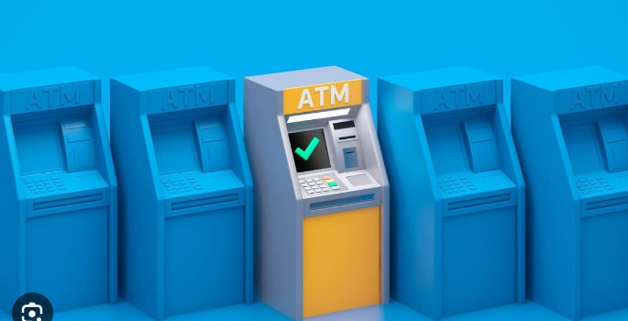

* ***Find an ATM:*** Select your bank's ATM to keep your transaction costs at zero. Local ATMs should process your card even if it belongs to another financial institution.
* ***Check for Security:*** Choose a well-lit ATM spot with video surveillance cameras and security equipment. Skip using an ATM if you do not feel protected at that spot.

**Step 2: Insert Your Card**

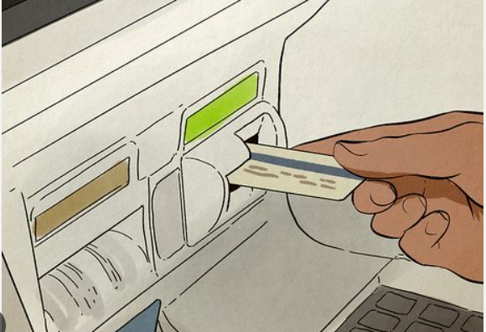

* ***Card Slot:*** Put your debit or credit card into the access point at the ATM. place your card with the magnetic strip or chip at your machine's proper alignment.
* ***Wait for Prompt:*** The ATM reads your card and then presents a welcome announcement.

**Step 3: Enter Your PIN**

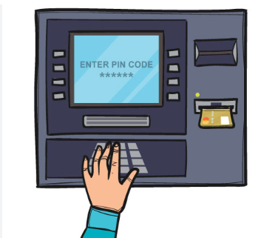

* ***Input PIN:*** Enter your four-digit PIN when prompted through the machine.
* ***Cover Your Input:*** Cover the keypad with your protective hand while you enter your PIN code.

**Step 4: Select Transaction Type**

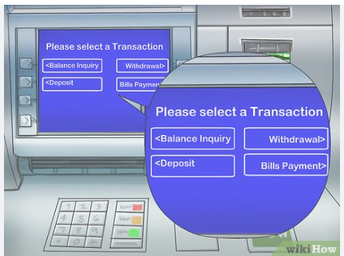

* ***Options Displayed:*** You can withdraw, deposit funds, check your balance, or view a mini statement when using the ATM.
* ***Choose Withdrawal:*** Hit the button labeled Cash Withdrawal.

**Step 5: Choose Account Type**

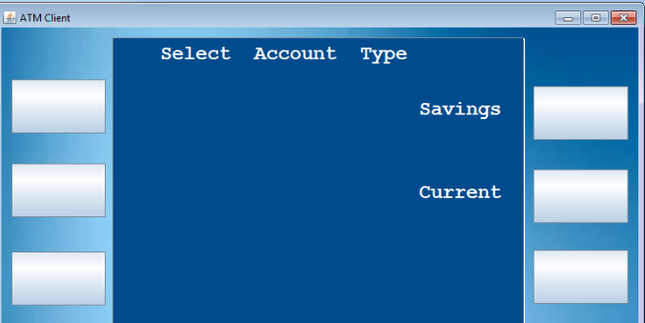

* ***Account Type:*** The ATM service demands knowledge of your account type before continuing. Pick Savings or Checking to continue as the account type matches the account associated with your card.
* ***Proceed:*** Choose to confirm to proceed with the process.

**Step 6: Enter the Amount**

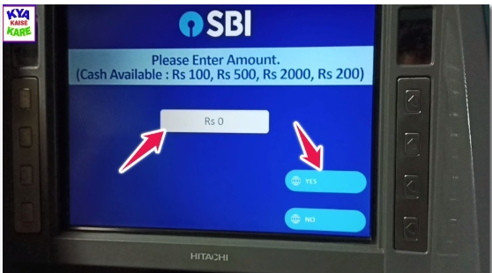

* ***Input Amount:*** Please key in the withdrawal amount you intend to receive. Make sure you pick an amount that fits inside your daily withdrawal cap and current account funds.
* ***Confirm:*** Verify your input and press the desired confirmation button to confirm your amount.

**Step 7: Collect Cash**

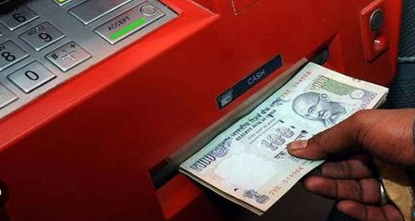

* ***Cash Dispensed:*** The machine will read and distribute money to the cash delivery opening.
* ***Quickly Retrieve Cash:*** Get your cash now since the ATM system will pull back any money that stays unclaimed for a short period.

**Step 8: Take your receipt if you want one**

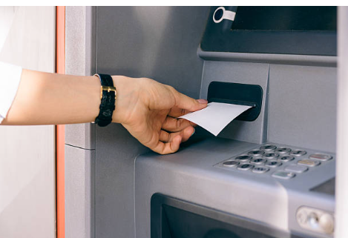

* ***Receipt Option:*** Your ATM may present an additional receipt selection.
* ***Choose Yes or No:*** Decide whether you need this service. Keep your printed receipt as proof of your transaction when you opt for this service.

**Step 9: Remove Your Card**

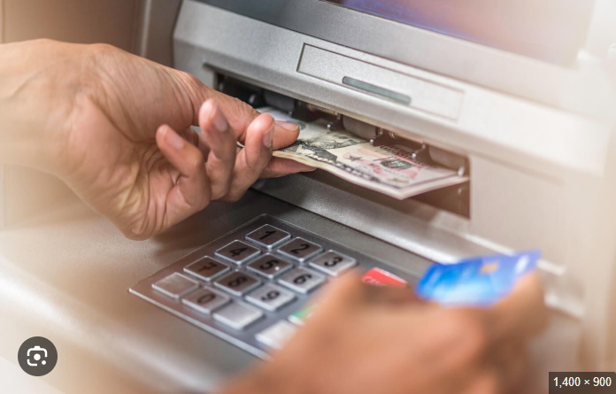

* ***Card Ejection:*** The ATM will automatically push out your card once your transaction finishes.
* ***Take Your Card:*** Grab your card and keep it in a safe place when you exit.

**Step 10: Verify Transaction**

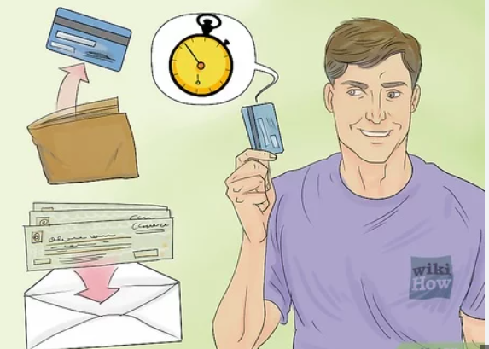

* ***Check Cash:*** Make sure the machine gives you exactly the amount you requested.
* ***Secure Your Cash:*** Put your cash into your wallet or purse while standing at the exit of the ATM.

**Safety Tips**

* Never share your PIN with others.
* Pay attention to what's going on around you searching for signs of wrongdoing.
* Save the receipt as proof for future financial logging.

By following these steps you can withdraw money safely without any problems.